**SESSSIN -6**



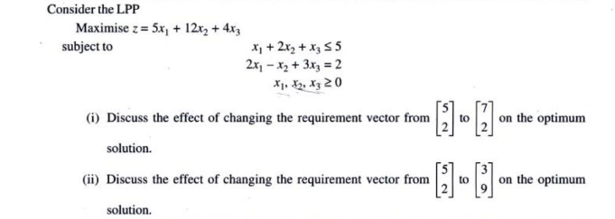

**SOLUTION: Big- M method final table is as follows**

